EE380 Project #2

Q1. Three points #1, #2, and #3 are selected at random from the circumference of a circle (see figure). Write Matlab code to find the probability that the three points lie on the same quarant. Plot the result.



Solution

clear all

experience=4000;

for i=1:experience

count=0;

b(1)=0; b(2)=0; b(3)=0;

a(1)=0; a(2)=0; a(3)=0;

for k=1:i

point=rand(1,3)\*360;

x=point;

b(1)=max(x);

b(3)=min(x);

for j=1:3

b(1)>x(j) && x(j)>b(3);

b(2)=x(j);

end

a(1)=b(1)- b(3);

a(2)=b(2)- b(3);

%a(3)=b(3)- b(3);

% For 90 degree calculation

if a(1)<=90 && a(2)<=90

count=count+1;

end

if a(1)>=270 && a(2)>=270

count=count+1;

end

if a(1)>=315 && a(2)<=45 && a(1)-a(2)>=270

count=count+1;

end

end

probability(i)=count/k;

end

plot(probability);

axis([0, experience, 0,inf]);

xlabel ('Test Times')

ylabel ('Probability (%)')

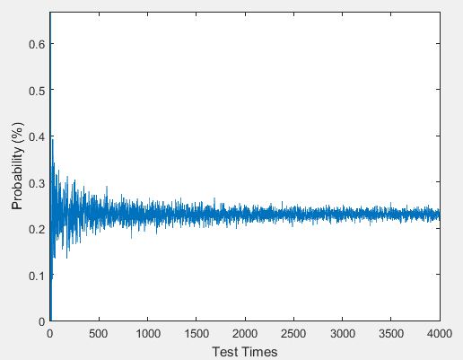

Q2.Use Matlab to calculate the probability to get 3 times of “5” in 8 throws of a fair die.

1. Using Binomial Distribution, and
2. Using Matlab to simulate it.

Solution1:

8C3(1/6)3(5/6)5 = 0.104

Solution 2:

clear all

expt=10000;

count=0;

a=[5 5 5];

for i=1:expt

point=randi(6,8,1);

if sum(ismember(point,a))==3

count=count+1;

end

end

prob=count/expt;

expt, prob

expt=10000

prob=0.1024

Q3. The probability to have exact3 boys in a 5 kids family, if

1. The birth rate of boy is equal to that of girl
2. If the birth rate of boy is 1/3 and girl is 2/3.

Please find the answer by using Matlab simulation

1. Binomial Distribution
2. P=q=1/2

5c3(1/2)3(1/2)2= 0.3125

1. P=1/3, q=2/3

5c3(1/3)3(2/3)2= 0.1646

1. Matlab
2. p=q=1/2

clear all  
experiment=20000; %number of experiments  
boys=0;   
count=0;

n=5; % kids number of whole family  
for k=1:experiment  
    kids=rand(1,n);  %generating kids in the family  
    for i=1:length(kids)

      if kids(i)>=0.5 %count the number of boys in one family, i assume that if the number is >=0.5, this is a boy.  
        boys=boys+1;  
      end  
    end  
      if boys==3  
        count=count+1; %if number of boys in this family is 3, then count 1  
      end  
    boys=0; %set the number of boys back to 0, and then re-run with different families.  
end  
prob=count/experiment;

prob, count

Prob=0.3181, count=3181

1. p=1/3 and q=2/3

clear all  
experiment=10000; %number of experiments  
boys=0;   
count=0;

n=5; % kids number of whole family  
for k=1:experiment  
    kids=rand(1,n);  %generating kids in the family  
    for i=1:length(kids)

      if kids(i)>=0.667 %count the number of boys in one family, i assume that if the number is >=0.5, this is a boy.  
        boys=boys+1;  
      end  
    end  
      if boys==3  
        count=count+1; %if number of boys in this family is 3, then count 1  
      end  
    boys=0; %set the number of boys back to 0, and then re-run with different families.  
end  
prob=count/experiment;

prob, count

prob=0.1632, count=1632